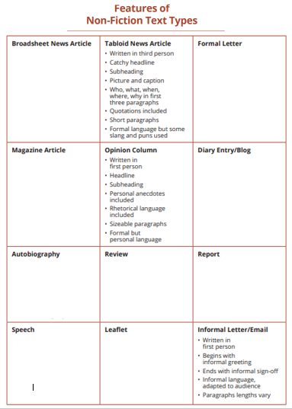

Score (Rating)

Begins with opinion

Salutation (Dear Diary)

First person

Describes the persons life

Basic vocabulary

Very descriptive

Date

Written in 1st person

Uses complex vocabulary

Formal Language

Includes recipients address, name and contact

Includes sender’s name

The date

Salutation (Dear, it must be marked with a comma